Hyper-V virtualization in Windows Server and Windows.

Introduction
Hyper-V is Microsoft’s enterprise-grade hypervisor technology built into Windows Server. General requirements are
- 64-bit processor with second-level address translation (SLAT).
- VM Monitor mode extensions.
- At least 4 GB of RAM.
- Virtualization support turned on in the BIOS or UEFI.
  - Hardware Assisted Virtualization
  - Hardware-enforced Data Execution Prevention.

System requirements for Hyper-V
Hyper-V can be enabled on Windows 10 Professional and Windows 11 Professional.
You can check your device for Hyper-V requirements
- Open Command Prompt and type Systeminfo.exe.
- Scroll to Hyper-V requirement section to review the port. If all listed Hyper-V requirements have a value of YES, your system can run the Hyper-V role.
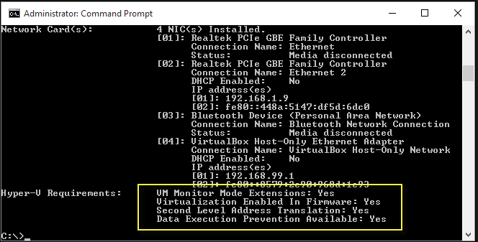
If Hyper-V requirements section reads:
“Hyper-V Requirements: A hypervisor has been detected. Features required for Hyper-V will not be displayed.”
It suggests that the systeminfo command was run on an existing Hyper-V host.

Install Hyper-V
Enable Hyper-V to create virtual machines on Windows.
- Navigate to the Control Panel. Select Start, then search for Control Panel to open the application.
- Select Programs, then Programs and Features.
- Select Turn Windows Features on or off.
- Select Hyper-V and then select OK.
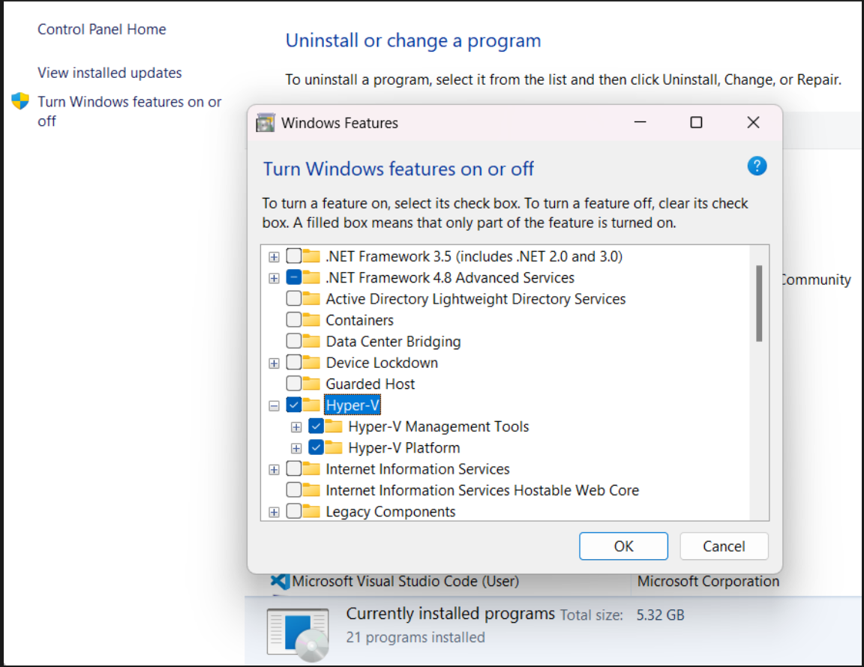
- To complete the installation, restart your computer.

Reference
System Requirements for Hyper-V on Windows and Windows Server | Microsoft Learn
Install Hyper-V in Windows and Windows Server | Microsoft Learn

